Here is a list of the Top 10 Grinches that Steal Christmas:

“A Grinch” in your thinking is where some aspects of ideas & experiences are given more weight & focus than others. We all do this both consciously & unconsciously, & how we do this provides pointers to our underlying beliefs about ourselves, others & the world.

Which of these might you be letting steal your Christmas and New Year?

- All or Nothing Thinking: Seeing things as black-or-white, right-or-wrong with nothing in between. Essentially, if I'm not perfect then I'm a failure.
- I didn't mail out Christmas cards to everyone on my list so it was a complete waste of time.
- There's no point in decorating if 100% of the lights don’t work!
- They didn't show, they’re completely unreliable!

- Overgeneralization: Using words like always, never in relation to a single event or experience.
  - I'll never get that promotion
  - She always does that…

- Minimising or Magnifying (Also Catastrophizing): Seeing things as dramatically more or less important than they actually are. Often creating a "catastrophe" that follows.
  - Because my boss publicly thanked her she'll get that promotion, not me (even though I had a great performance review and just led an outstanding Christmas pageant).
  - I forgot to text her back! That means she won't trust me again, I won't be invited again and all my friends will leave me.

- "Shoulds": Using "should", "need to", "must", "ought to" to motivate oneself, then feeling guilty when you don't follow through (or anger and resentment when someone else doesn't follow through).
  - I should have got the Christmas shopping done this weekend.
  - They ought to have been more considerate of my feelings, they should know that would upset me.

- Labeling: Attaching a negative label to yourself or others following a single event.
  - I forgot to buy the egg nog, I'm such a idiot!
  - What an insensitive doofus, he couldn't even look up from his phone to help that lady with her cart!

- Jumping to Conclusions:

1) Mind-Reading: Making negative assumptions about how people see you without evidence or factual support.
Your friend is preoccupied and you don't bother to find out why. You're thinking:
  - She thinks I'm exaggerating again. or
  - He still hasn't forgiven me for not going to his party.

2) Fortune Telling: Making negative predictions about the future without evidence or factual support

  - I won't be able to lose weight and I'll be stuck with this shape forever! (even though you just started to cut out sugar).
  - No-one will understand. I won't be invited back again (even though they are supportive friends).

- Discounting the Positive: Not acknowledging the positive. Saying anyone could have done it or insisting that your positive actions, qualities or achievements don't count…
  - That doesn't count, anyone could have done it.
  - I've only cut back desserts to 3x/week, but that doesn't count because I've not fully given up yet.

- Blame & Personalization: Blaming yourself when you weren't entirely responsible or blaming other people and denying your role in the situation
  - If only I was younger, I would have got the job
  - If only I hadn't said that, they wouldn't have…
  - If only she hadn't yelled at me, I wouldn't have been angry and wouldn't have had that car accident.

- Emotional Reasoning: I feel, therefore I am. Assuming that a feeling is true - without digging deeper to see if this is accurate.
  - I feel like such a loser (it must be true).
  - I feel guilty (I must have done something wrong).
  - I feel really bad for yelling at my child, I must be really selfish and unloving.

- Mental Filter: Allowing (dwelling on) one negative detail or fact to spoil our enjoyment, happiness, hope etc
  - You have a great evening and dinner with friends, but your chicken was undercooked and that spoiled the whole evening.

Summing it all up, friends,
I'd say you'll do best by filling your minds and meditating
on things true, noble, reputable, authentic, compelling, gracious—
the best, not the worst; the beautiful, not the ugly; things to praise, not things to curse. Do that, and God, who makes everything work together,
will work you into his most excellent harmonies.
Philippians 4:8-9 (MSG)

MERRY CHRISTMAS!

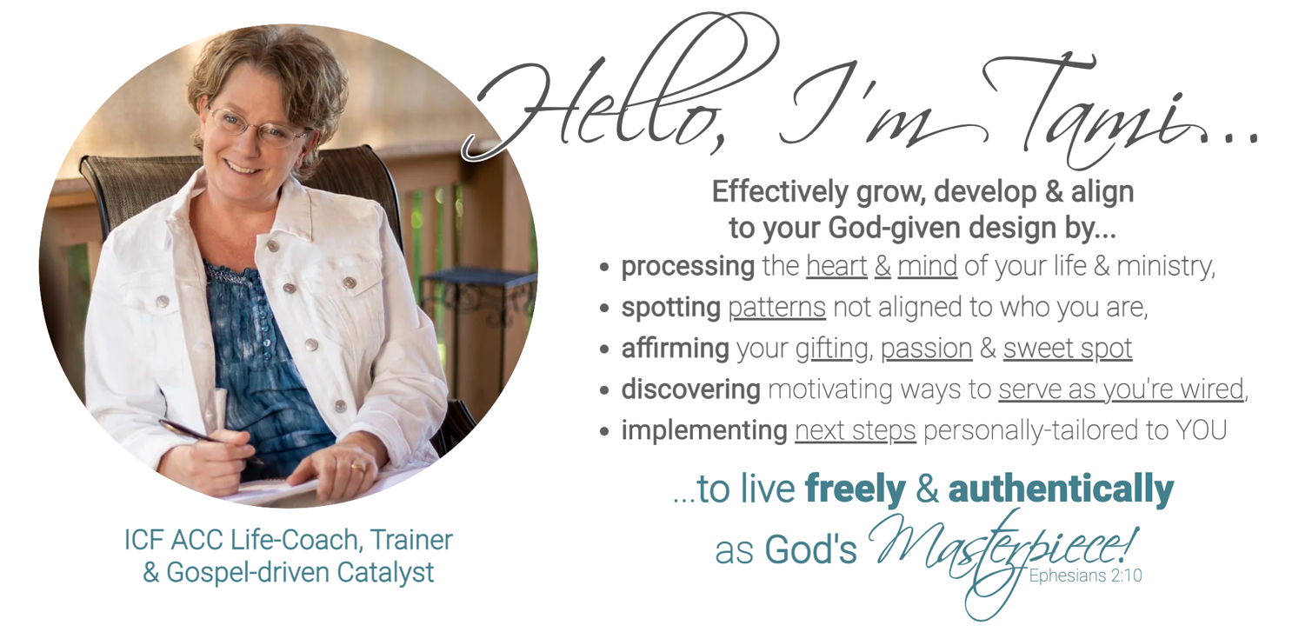

Let’s Begin a Coaching Journey Together for a REaligned New Year!
www.tamithorsencoaching.com

